COMMUNITY EMPOWERMENT (SCOTLAND) ACT 2015
ASSET TRANSFER REQUEST FORM

Polmont Playgroup
Community Asset Transfer - Action Outdoors, Brightons, FK2 0AA

IMPORTANT NOTES:
You do not need to use this form to make an asset transfer request, but using a form will help you to make sure you include all the required information.
You should read the asset transfer guidance provided by the Scottish Government before making a request.
You are strongly advised to contact the authority and discuss your proposals with us before making an asset transfer request.
When completed, this form must be sent to Falkirk Council which owns or leases the land your request relates to.

This is an asset transfer request made under Part 5 of the Community Empowerment (Scotland) Act 2015.
- Information about the community transfer body (CTB) making the request
  - Name of the CTB making the asset transfer request
Polmont Playgroup
  - CTB address. This should be the registered address, if you have one.
Postal address:
Greenpark Community Centre, Greenpark Drive, Polmont

Postcode: FK2 0PZ
  - Contact details. Please provide the name and contact address to which correspondence in relation to this asset transfer request should be sent.
Contact name: [REDACTED]
Postal address: [REDACTED]

Postcode: FK2 9TF
Email: PolmontPlaygroupCommittee@gmail.com
Telephone: [REDACTED]
 We agree that correspondence in relation to this asset transfer request may be sent by email to the email address given above. (Please tick to indicate agreement)
You can ask Falkirk Council to stop sending correspondence by email, or change the email address, by telling them at any time, as long as 5 working days’ notice is given.
  - Please mark an “X” in the relevant box to confirm the type of CTB and its official number, if it has one.
 | Company, and its company number is ………….
x | Scottish Charitable Incorporated Organisation (SCIO), and its charity number is ……………….. | SC053631
 | Community Benefit Society (BenCom), and its registered number is ………………………………
 | Unincorporated organisation (no number)

Please attach a copy of the CTB’s constitution, articles of association or registered rules.
  - Has the organisation been individually designated as a community transfer body by the Scottish Ministers?
No ☐
Yes ☐
Please give the title and date of the designation order:
n/a
  - Does the organisation fall within a class of bodies which has been designated as community transfer bodies by the Scottish Ministers?
No ☐
Yes ☐
If yes, what class of bodies does it fall within?
Community Controlled Body

- Information about the land and rights requested
  - Please identify the land to which this asset transfer request relates.
You should provide a street address or grid reference and any name by which the land or building is known. If you have identified the land on the relevant authority’s register of land, please enter the details listed there.
It may be helpful to provide one or more maps or drawings to show the boundaries of the land requested. If you are requesting part of a piece of land, you must attach a map and full description of the boundaries of the area to which your request relates. If you are requesting part of a building, please make clear what area you require. a drawing may be helpful.
Action Outdoors, Canal Bridge, Brightons FK2 0AA
274.86 GIA (sqm)
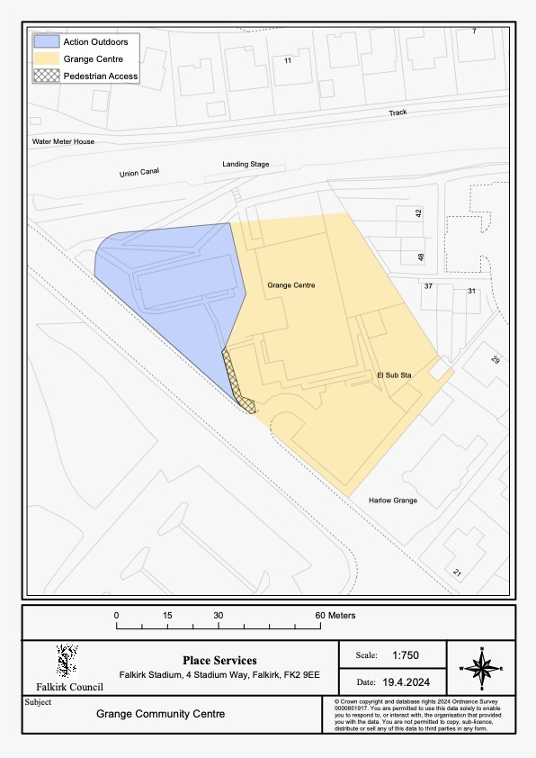
  - Please provide the UPRN (Unique Property Reference Number), if known.
Please see Falkirk Council’s register of land assets for UPRN
UPRN: 136087289

- Type of request, payment and conditions
  - Please tick what type of request is being made:

for ownership (under section 79(2)(a)) - go to section 3A

for lease (under section 79(2)(b)(i)) – go to section 3B

for other rights (section 79(2)(b)(ii)) - go to section 3C

3A – Request for ownership
What price are you prepared to pay for the land requested?:
Proposed price: £1.00
Please attach a note setting out any other terms and conditions you wish to apply to the ownership request.
1. Before taking over the property, the name of the building is changed to ‘Polmont Playgroup’ from ‘Action Outdoors’ in the address to avoid confusion.

2. Both parties will cover their own legal expenses, when incurred.

3. Before taking over the property, we propose the carpark is changed to shared use between the two assets. We therefore request access rights, vehicle access and will form a joint maintenance agreement for upkeep and we will jointly fund plans to extend the number of spaces.

4. There is a large yellow container which sits in the Grange boundary but seems to be alarmed from the Action Outdoors building. Neither party wants to keep this container therefore we would like to request it was separated from the AO alarm system and removed from site.

3B – request for lease
What is the length of lease you are requesting?

How much rent are you prepared to pay? Please make clear whether this is per year or per month.
Proposed rent: £ per year
Please set out any other terms and conditions you wish to be included in the lease, or to apply to the request in any other way.

3C – request for other rights
What are the rights you are requesting?
Do you propose to make any payment for these rights?
Yes ☐
No ☐
If yes, how much are you prepared to pay? Please make clear what period this would cover, for example per week, per month, per day?
Proposed payment: £ per
Please set out any other terms and conditions you wish to apply to the request.

Community Proposal
  - Please set out the reasons for making the request and how the land or building will be used.
This should explain the objectives of your project, why there is a need for it, any development or changes you plan to make to the land or building, and any activities that will take place there.
Polmont Playgroup has existed in Polmont for 52 years. It all began in the former Polmont Community Hall; however, Falkirk Council closed this facility in 1997 where we then moved to Greenpark Community Centre. Unfortunately, with the SPR, Falkirk Council have again issued Polmont Playgroup with an eviction notice to 31st October 2024. The community group looking to take over the Greenpark Centre have voted for demolishing the annex building where Polmont Playgroup permanently reside and have confirmed to us that they cannot relocate our service into the main hall, which will exist, as we are simply too large. Therefore, we are soon to find ourselves homeless as part of this action.
Polmont Playgroup, now in survival mode, were seeking alternative premises when we saw the Action Outdoors Centre and quickly realised this was an ideal location for our service and in fact the exact size we need. We have a waiting list of children up to the end of 2026 therefore we know there is demand for our service and we have a lot of community support to continue our service.
We will need to refurbish the interior of the building, not that it is in disrepair, solely to remove the showers/changing areas and reduce the number of walls as a larger open plan area works better for our setting. We need to fence-off the garden area so children can enjoy outdoor learning and play in the garden space, and we would also look to relocate our outdoor play items (sand pit, Wendy/playhouse, bench) from our current setting to the new space.
Our basic service will be as-is, a supervised Playgroup term time, Mon-Fri between 9.30-11.30am – staff onsite between 9am-12.30pm. We would love to add on additional children related services in the afternoons, offering the space to other community groups/organisations. We have trialled this in our current setting with BookBug and Kids Yoga.
Our continued aim is to be the Playgroup of choice in our community and provide a much-loved Playgroup service to all children regardless of background or ability in the local community where they can learn and develop through play.
We strive to advance the education & social development of pre-school children with the emphasis on the play experience, so that they take a constructive place in the community and advance the education of their parents/carers. We do this with the guidance of Early Years Scotland.
We shall continue to seek to:
- provide a safe and satisfying group play and learning to all children
- encourage charitable activities through which parents and the community may support the development of children
- encourage an open and relaxed environment where everyone’s opinions and ideas are listened to and valued
- offer children a variety of carefully planned activities and learning experiences designed to develop positive learning attitudes and maximise opportunities to develop individual’s abilities
- promote a welcoming and caring ethos by showing care and respect for everyone and developing positive social and physical well-being
- spot and provide support and guidance to any child/parent/carer as required in our Safe-Guarding Policy
Benefits of the proposal
  - Please set out the benefits that you consider will arise if the request is agreed to.
This section should explain how the project will benefit your community, and others. Please refer to the guidance on how the relevant authority will consider the benefits of a request.
Polmont Playgroup will be able to continue with our invaluable 52-year-old service to the community.
Support child development and wellbeing - by providing a variety of activities, where children learn through play and build their independence, setting the foundations for early years education and beyond. We identify each child as an individual and respect and cater to the needs of each.
Assist in language development of young children - through regular music, group/ individual story time and sign language - parents feedback noticeable development.
Increase social interaction - helping children to build social relationships away from parents/carers, learn boundaries, develops friendships, and develop empathy for others.
Promote public health - by way of encouraging physical movement and outdoor play. We also offer a healthy snack and teeth brushing at each session for every child.
Reducing inequalities - our rates are lower than other childcare providers and we offer funded places to parents and carers who otherwise couldn’t afford our service. Meaning children do not miss out on everyday fun.
Tackle poverty - by providing high quality early education, a healthy snack and early help services, this helps ameliorate the effects of poverty on children and families by supporting children's development and improving educational outcomes. We have poverty stricken surrounding villages who benefit from this.
increased social interaction and support welfare - allowing, particularly isolated, parents the chance to meet other parents with children of a similar age and liaise with play leaders on the development of their child/seek advice. Parents can form friendships, build a supportive network, and gain an increased sense of community connectedness. Allowing for better communications between peers both adults and children.
Health Education for adults - We provide free child first-aid, child CPR sessions and other similar pivotal services to parents.
Support improved mental health - giving parents a couple of child-free hours to focus on something they enjoy or simply ‘get a break’, in the comfort and knowledge that their child is safe and happy. Creating some breathing space and balancing out the mental load.
Wellbeing support - we regularly update information via email, on our social media and notice boards to advertise support available for parents and children. Our staff are friendly and approachable for parents who need further support for their child or themselves. Our staff are all trained in safeguarding and the necessary processes.
Ease financial pressure - we provide vital early services which many parents couldn’t afford in a full day’s care in other setting. Giving parents the opportunity to access childcare/play settings before government funded places begin (and beyond).
Economic development of our local community - we provide multiple work experience placements to provide experience, permanent & casual employment opportunities in early childcare - most suited to those with young families themselves. Offer our staff funded training courses to encourage professional development. Support local child related businesses, providing them with an affordable venue for their service.
Environmental mindfulness - we offer a clothing recycling bin, battery recycling, tetra Pak recycling and ink cartridge recycling points - all helping our fundraising. Lead by example, reducing our carbon footprint.

Restrictions on use of the land
  - If there are any restrictions on the use or development of the land, please explain how your project will comply with these.
Restrictions might include, amongst others, environmental designations such as a Site of Special Scientific Interest (SSI), heritage designations such as listed building status, controls on contaminated land or planning restrictions.
Not aware of any. Change of use requests, application no: ENQ/2024/0645
Negative consequences
  - What negative consequences (if any) may occur if your request is agreed to? How would you propose to minimise these?
You should consider any potential negative consequences for the local economy, environment, or any group of people, and explain how you could reduce these.
Capacity to deliver
  - Please show how your organisation will be able to manage the project and achieve your objectives.
This could include the skills and experience of members of the organisation, any track record of previous projects, whether you intend to use professional advisers, etc.
Polmont Playgroup has a proven track record of 52 years running a successful service. We have a team of paid permanent staff, bank staff, volunteers and a strong Management Committee. We are experienced in staff management and recruitment, marketing, fundraising, childcare and generally managing our Playgroup.
We successfully survived lockdown, including continuing to pay our staff as we were able to keep up fundraising, moving most of it online and holding safe social distancing outside events. Polmont Playgroup received an award from the Scottish Government for Community Involvement for our efforts.
We have enlisted the help of a surveyor to provide the valuation on the building, an Architect to provide drawings of the current building and the future layout plans and a lawyer to aid in the negotiation of the CAT contract on our behalf.
To ensure the premises are suitable for a Playgroup setting, we will utilise the services (and charity) of local trades people to achieve this. We have identified 3 each of the following tradespeople (and had initial discussions with some): Plumbers, Electricians, Joiners, Flooring specialist, Heating engineer, Plasterer, Painter and signage.
We have a strong team of willing and able staff and volunteers who actively help and have agreed to participate in the transformation of the building to keep costs down. This effort is reflected in every activity we undertake. We have volunteer support from Neighbourly and FareShare and in tandem access to B&Q, M&G, M&S, Lidl, ASDA and Aldi volunteers offering 2 days per calendar year per employee - many who have committed to assisting our transition.

- Level and nature of support
  - Please provide details of the level and nature of support for the request, from your community and, if relevant, from others.
This could include information on the proportion of your community who are involved with the request, how you have engaged with your community beyond the members of your organisation and what their response has been. You should also show how you have engaged with any other communities that may be affected by your proposals.
Polmont Playgroup have a waiting list to the end of 2026 for our service, and this level of demand is common practice for us. Our service is open to anyone in the community, and we regularly involve the community and local businesses in our Fundraising events to say ‘thank you’ for their on-going support.
We consulted our community for feedback via social media, making use of local Community Facebook Groups and received 126 responses and an overwhelming positive level of encouragement. 100% of people surveyed agreed that Polmont Playgroup was a valuable service to the community, including 17% who had never used our service.
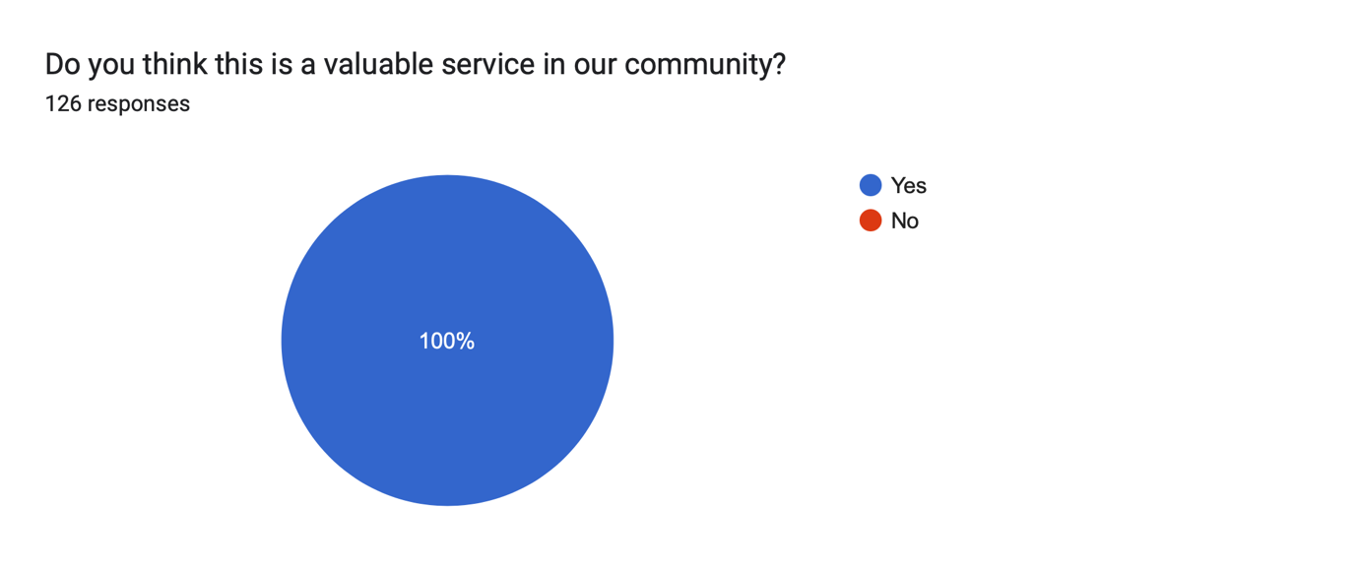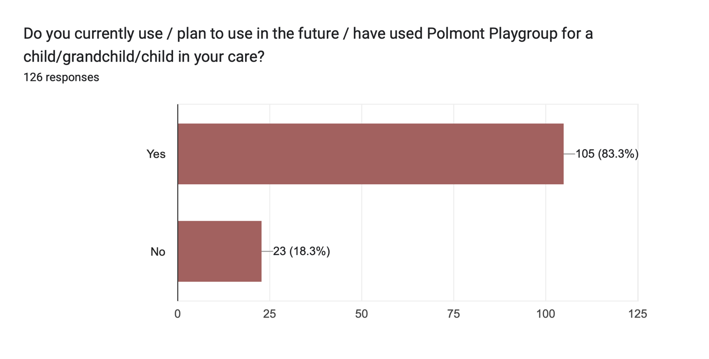
In an independent Facebook Post on a community Group, a member of the public asked the community for their preference of the two Playgroups in the area. The response was 75% in favour of Polmont Playgroup with 30 comments.
We have been working closely with the Grange Community Centre to develop their SCIO and CAT application and in the process we have been discussing the positive ways in which the two charitable organisations can benefit from each other’s existence and work in partnership to promote our services to the community. We will have 25 children and their parents coming to the Playgroup each day therefore will have the opportunity to advertise the activities of the Grange Centre to these parents who otherwise may not have been onsite at the Grange or aware of the offering. Therefore, increasing footfall to the Centre also.

- Funding
  - Please outline how you propose to fund the price or rent you are prepared to pay for the land, and your proposed use of the land.
You should show your calculations of the costs associated with the transfer of the land or building and your future use of it, including any redevelopment, ongoing maintenance and the costs of your activities. All proposed income and investment should be identified, including volunteering and donations. If you intend to apply for grants or loans you should demonstrate that your proposals are eligible for the relevant scheme, according to the guidance available for applicants.
Polmont Playgroup is currently self-sustainable and can afford to absorb the £1 proposed purchase cost into our current fee’s vs staff and overheads costs calculations.
As shown in the below payments and receipts projections, our fees and the standard fundraising (amounts taken as an average over the last 5 years) we do every year within the Playgroup (as opposed to the additional Adhoc community fundraising events we hold) cover our payments, some of which are exaggerated and many are non-essential, therefore do not need to be spent.
Spending on snacks can be greatly reduced as we receive weekly food donations from Neighbourly and FareShare in partnership with Asda, M&S, Booker and Aldi which allow us to keep our snack costs down. We also have access to Tesco and Sainsburys food donations. We regularly share these donations with identified families in need in our community and will continue to support.
Additionally, our parents are very generous in using our ‘Amazon Thank You Wish List’ and regularly purchase toys and supplies for the playgroup in response to our cunning marketing. Therefore, this reduces our requirement to buy new toys.
We plan to promote Easy Fundraising again in the future, as we have not promoted for a few years therefore donations have dwindled. In previous years we have received up to £800.
Also, we plan to continue our Community Fundraising events to bring in additional funds to give us freedom, flexibility and further financial security.
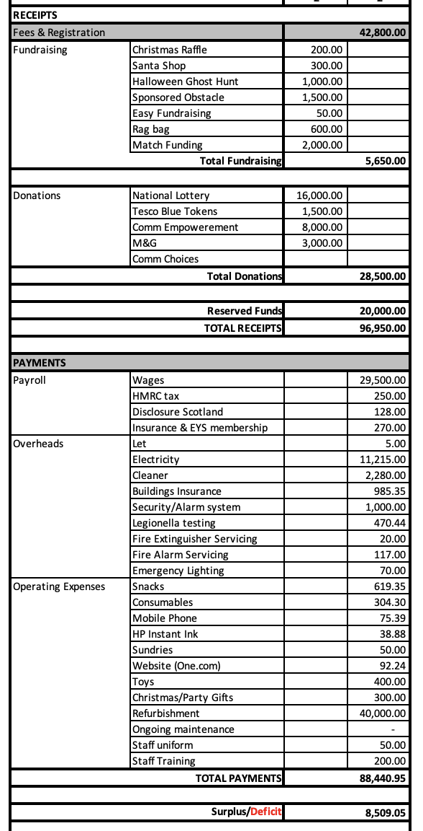
We have 3 trustees each working 20 hours per week. This expertise equates to £40 per hour, in line with their current employment. Additionally, we have 10 volunteers, each working a total of 2 hours per week. Their expertise equates to £12 per hour. Together this saves a total of 3,360 paid hours per year at a cost of £217,680. Looking at these projections over 5 years, the savings would be:
Year 1 - £127,690
Year 2-3 - £268,923
Year 4-5 - £288,077
(using 3.5% inflationary increase year on year)
It is standard practice for our dedicated committee team to fundraise in general, whether that be through events such as our recent Fun Day in June 2024 where we raised £4,000 with the help of match funding. We also apply for grants on a regular basis to purchase new toys or refurbish our current garden space for example. Having received almost £9k in the last 2 years from Neighbourly, Howdens, ASDA, Tesco and M&G.
For the refurbishment project in the new proposed Action Outdoors building, we have £20k reserved in our bank account and we have been applying and identifying additional applicable grants:
National Lottery Community Led £19,500 – Awarded
Tesco Blue Tokens £1.5k – Approved and waiting to go-live in store
Community Empowerment Capital Grant £7,998.79k - Application submitted
Community Empowerment CAT Grant £7,360 – Awarded
M&G Community Grant £4.9k – Awarded
National Lottery Awards for All – Yet to apply
Find below proof of our Income and Expenditure over the last 5 years. Our spending has increased due to available funds generated from fundraising and grants. 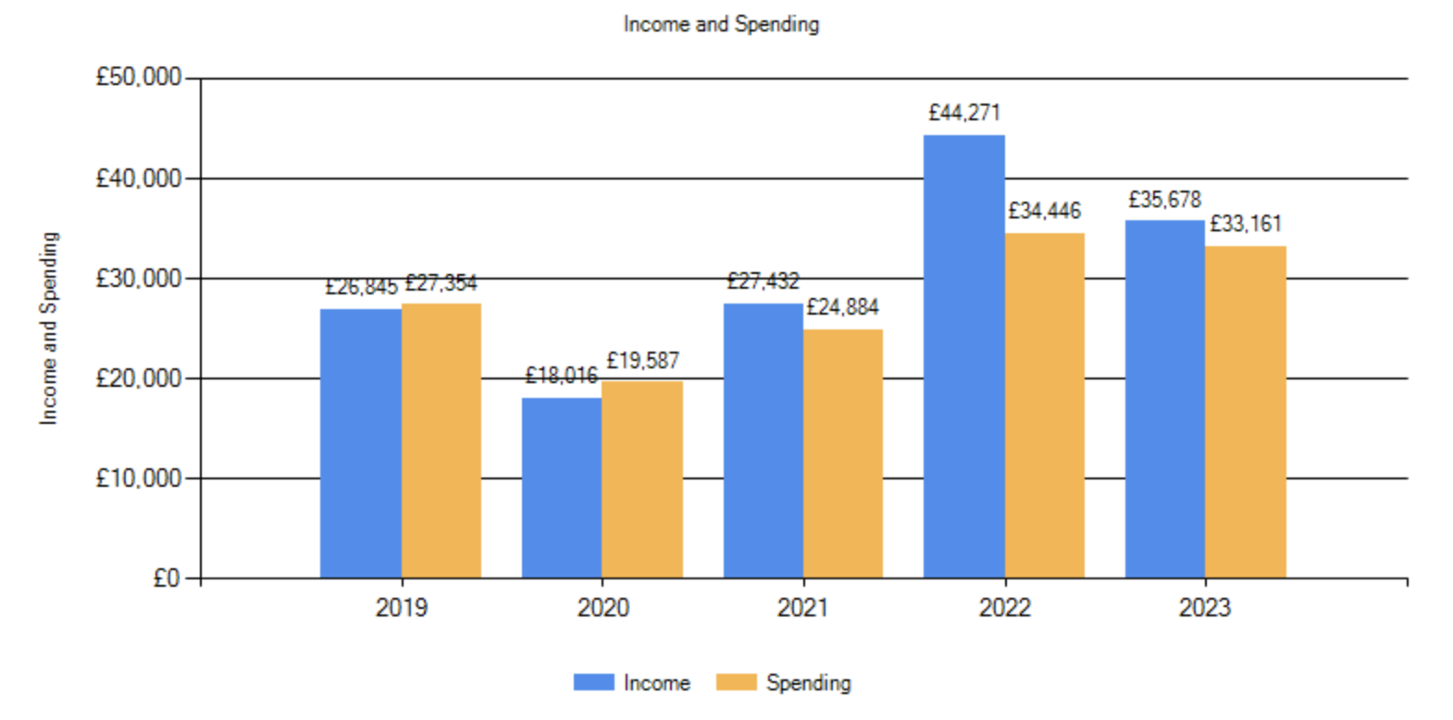
Signature
Two office-bearers (board members, charity trustees or committee members) of the community transfer body must sign the form. They must provide their full names and home addresses for the purposes of prevention and detection of fraud.
This form and supporting documents will be made available online for any interested person to read and comment on. Personal information will be redacted before the form is made available.

We, the undersigned on behalf of the community transfer body as noted at section 1, make an asset transfer request as specified in this form.
We declare that the information provided in this form and any accompanying documents is accurate to the best of our knowledge.
Name [REDACTED]
Address [REDACTED]
Date 30th June 2024
Position Chair
Signature [REDACTED]

Name [REDACTED]
Address [REDACTED]
Date 30th June 2024
Position Treasurer
Signature [REDACTED]

Checklist of accompanying documents
To check that nothing is missed, please list any documents which you are submitting to accompany this form.
Section 1 – you must attach your organisation’s constitution, articles of association or registered rules
Title of document attached: Polmont Playgroup Constitution 2024

Section 2 – any maps, drawings or description of the land requested
Documents attached: n/a pasted into Request document

Section 3 – note of any terms and conditions that are to apply to the request
Documents attached:

Section 4 – about your proposals, their benefits, any restrictions on the land or potential negative consequences, and your organisation’s capacity to deliver.
Documents attached:

Section 5 – evidence of community support
Documents attached:

Section 6 – funding
Documents attached:

